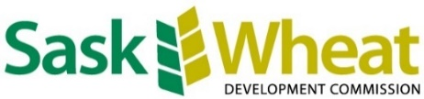
NEWS RELEASE
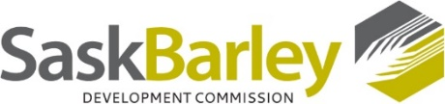
FOR IMMEDIATE RELEASE
June 14, 2023

Director nominations for barley and wheat commissions now open

SASKATOON, SK - The nomination period for director positions with both the Saskatchewan Barley Development Commission (SaskBarley) and the Saskatchewan Wheat Development Commission (Sask Wheat) is now open.

SaskBarley will have three director positions open. Sask Wheat will be looking to fill four open director positions pending regulatory approval to increase board size from seven to eight directors. The deadline to receive completed nomination forms for both organizations is Sept. 6, 2023, at 12 p.m. Should the organizations receive more nominations than there are director positions available, elections will be declared and held during the period of Oct. 19 to Nov. 29, 2023.

To be eligible to stand as a candidate, nominees must be registered producers, meaning they have had a Sask Wheat or SaskBarley check-off deducted since Aug. 1, 2021, and have not requested or received a refund of check-off in the last fiscal year (Aug. 1, 2022 - July 31, 2023) for each respective commission. All nominations must include the contact information of the nominee and signatures from at least two registered wheat producers for a Sask Wheat nomination or two registered barley producers for a SaskBarley nomination.

Nomination forms and election information can be found on the websites of each commission:

- saskbarley.com
- saskwheat.ca
- 30 -

For more information, please contact:

Contact:

Montana Getty
Sask Wheat
Communications & Events Coordinator
306-653-7975
comms@saskwheat.ca
Cole Christensen
SaskBarley
Communications Manager
306-250-1099
cole@saskbarley.com

