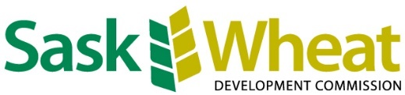
NEWS RELEASE
FOR IMMEDIATE RELEASE
May 15, 2023

Sask Wheat approves unprecedented $1.6 million funding to Saskatchewan AgriARM sites
SASKATOON, SK - Sask Wheat has approved $1.6 million in funding over two years to the eight Saskatchewan AgriARM sites. Each site will receive $200,000 which is going towards extension capacity, purchasing new equipment and furthering agronomic research which can increase wheat and whole-farm profitability.
AgriARM is a network of producer-directed applied research and demonstration organizations located across Saskatchewan. Each site operates individually and strives to collaborate on a broad range of projects to generate results relevant to growers over a wide area. AgriARM sites are supported by core funding from the Saskatchewan Ministry of Agriculture and receive the majority of funds through project-based funding from governments, commodity groups and private industry.

“The AgriARM research sites have conducted important research for Saskatchewan farmers over the last few years, from testing the effects of post-anthesis UAN on wheat protein to evaluation of row spacing and seeding density on the crop development and yield,” said Sask Wheat Chair, Brett Halstead. “Sask Wheat is pleased to provide AgriARM researchers with the funding they need to continue their research and provide Saskatchewan farmers with unique, Saskatchewan-based and regionally specific agronomic tools and techniques that will provide benefits to their farms.”

“The research and extension activities performed at the AgriARM sites have been valuable to Saskatchewan’s crop producers, leading to the adoption of state-of-the-art technologies and techniques,” said Constance Chiremba, Sask Wheat Research Program Manager. “This investment in the equipment and capacity of the research stations is an investment in the future of Saskatchewan’s wheat producers, as we will allow AgriARM researchers to continue their excellent work and communicate their results across the province.”

Sites:

- Indian Head Agri Research Foundation
- Conservation Learning Centre
- East Central Research Foundation
- Irrigation Crop Diversification Corporation
- Northeast Ag Research Foundation
- Southeast Research Farm
- Wheatland Conservation Area Inc.
- Western Applied Research Corp

Contact:
Montana Getty
Communications & Events Coordinator
306-653-7975
comms@saskwheat.ca

